Wireshark Lab 6-1

202022300317 杨业昶

## Step 1: Capture a Trace

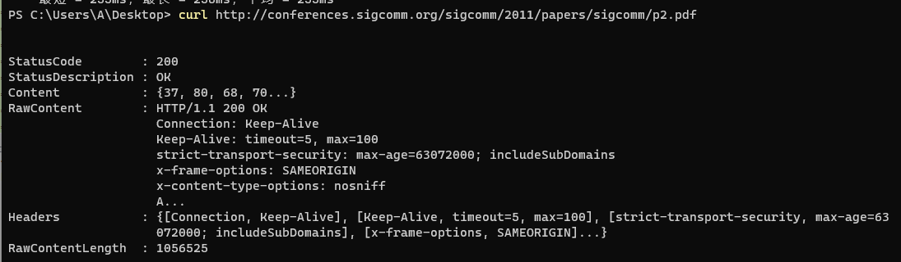

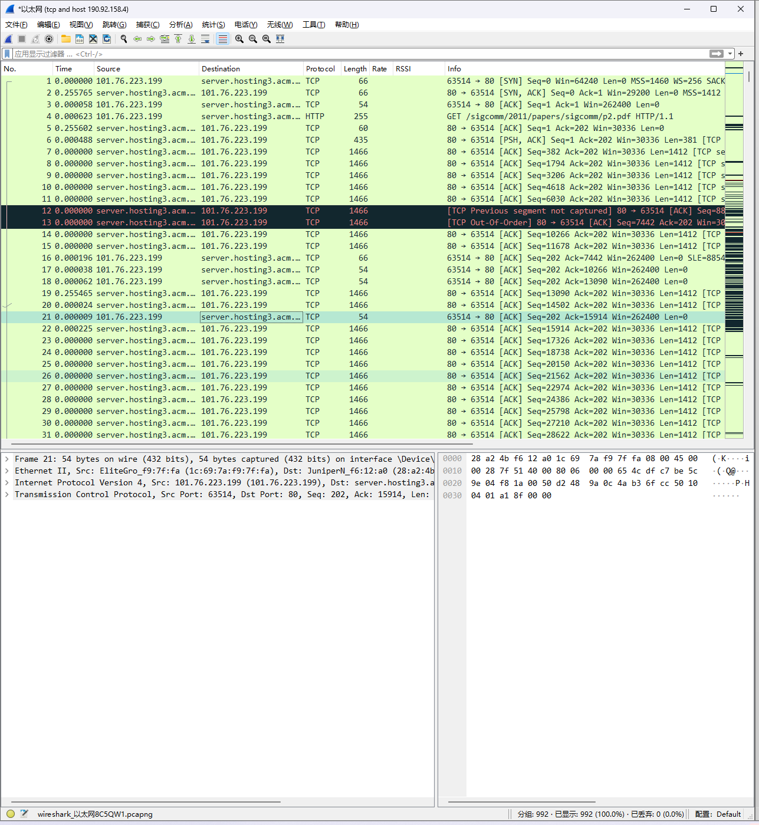

## Step 2: Inspect the Trace

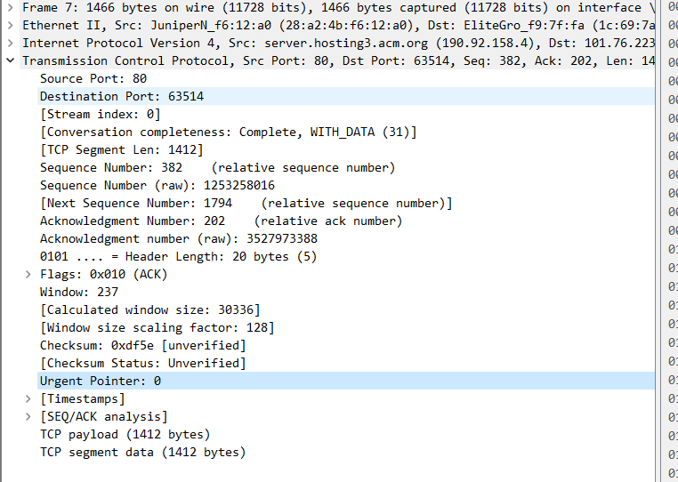

## Step 3: TCP Segment Structure

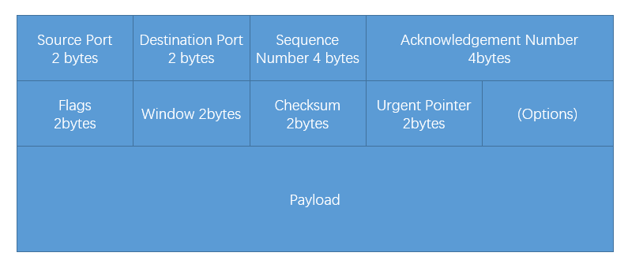

## Step 4: TCP Connection Setup/Teardown

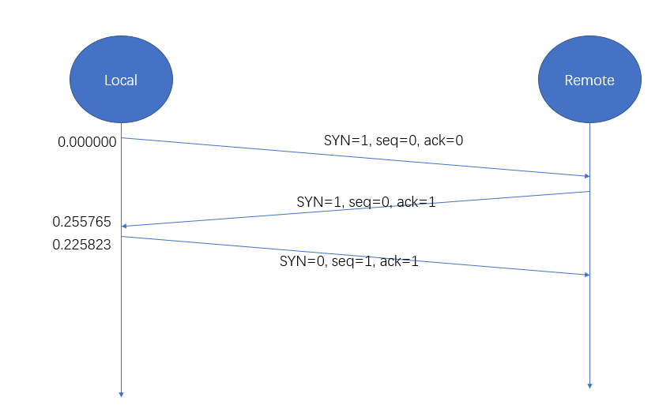

## Step 5: Connection Options

What TCP Options are carried on the SYN packets for your trace?

>>> SYN, ACK

## Step 6: FIN/RST Teardown

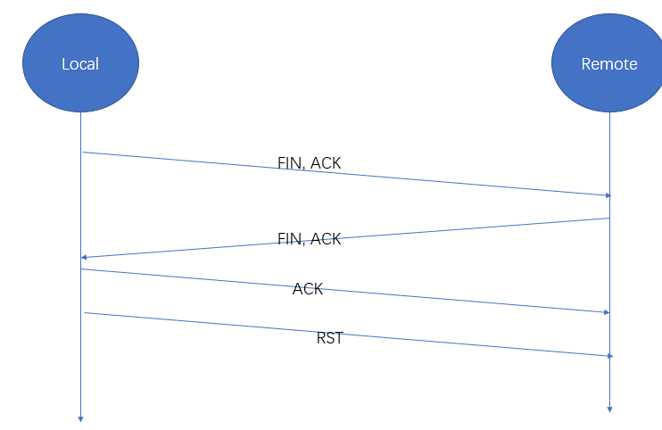

## Step 7: TCP Data Transfer

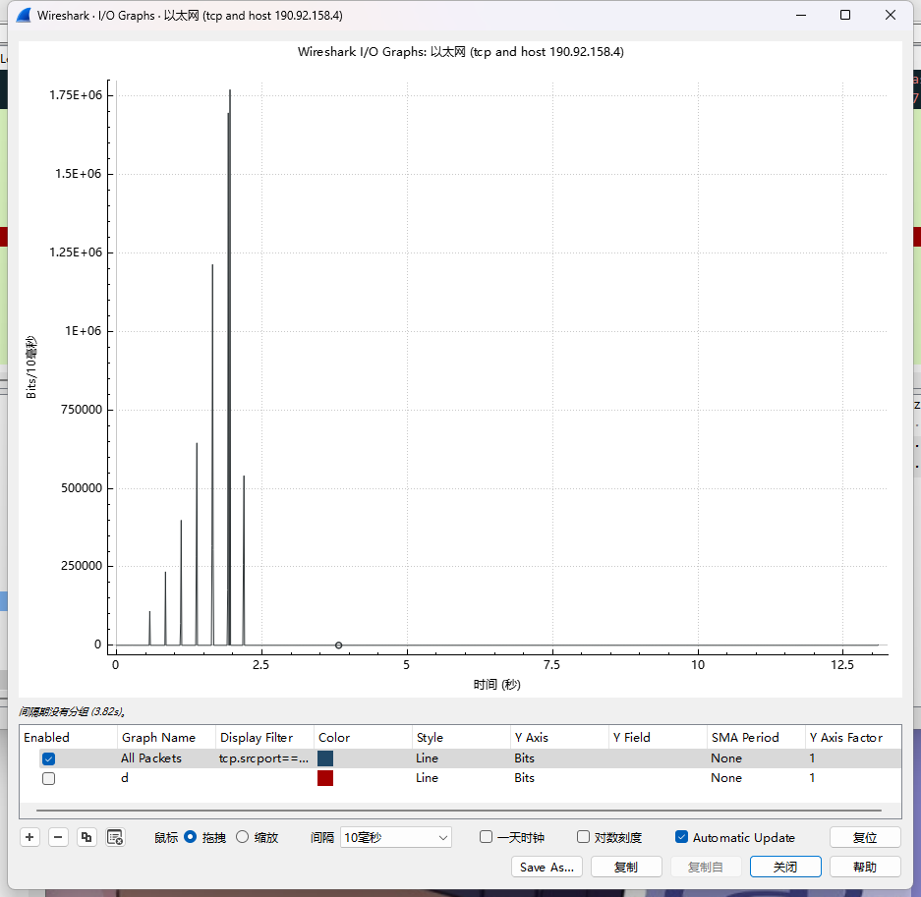

What is the rough data rate in the download direction in packets/second and bits/second once the TCP connection is running well?

>>> 6Mbps

What percentage of this download rate is content?

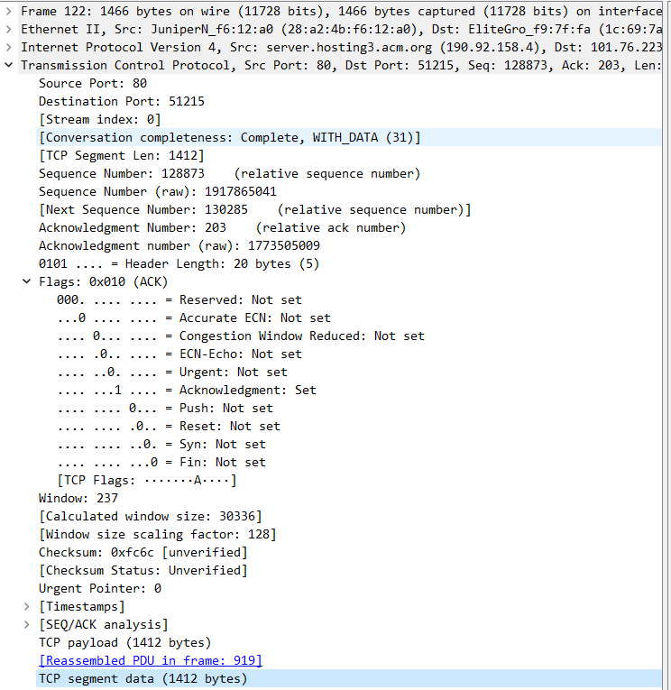

>>> 1412*8bit / 11728bit = 96.3%

What is the rough data rate in the upload direction in packets/second and bits/second due to the ACK packets?

>>> 60Kbps

If the most recently received TCP segment from the server has a sequence number of X, then what ACK number does the next transmitted TCP segment carry?

>>> X + TCP payload bytes